**Line Graph Guided Practice – Answer Key**

*Answers are shown in* ***red****.*

**Graph 1**

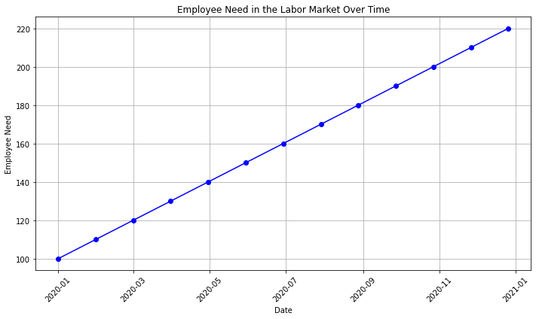

1. What is the title of the graph? **Employee Need in the Labor Market Over Time**
2. What information is on the X-axis? **Employee Need**
3. What information is on the Y-axis? **Date**
4. According to the graph, is there a demand for employees in the labor market? **Yes – The line has a positive slope (rising from left to right).**
5. In March 2020, how many employees were needed in the labor market? **120**
6. How many more employees were added to the labor market between May 2020 and November 2020? **60**
7. Do you think it would be easy or difficult to find a job in this labor market? Why? **Easy, because the demand for labor is increasing steadily.**

**Graph 2**

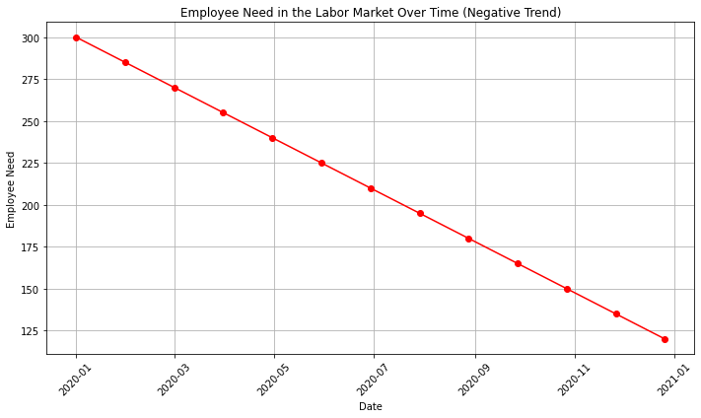

1. According to the graph, is the demand for employees growing? How do you know?

**No – The line has a negative slope (declining from left to right).**

1. How many employees were needed in the labor market in July 2020 compared to January 2021?

**July 2020 – approximately 210; January 2021 – approximately 120**

**There is a difference of 90.**

1. Do you think it would be easy or difficult to find a job in this labor market? Why?

**Difficult, because the demand for labor is decreasing steadily.**

**Graph 3**

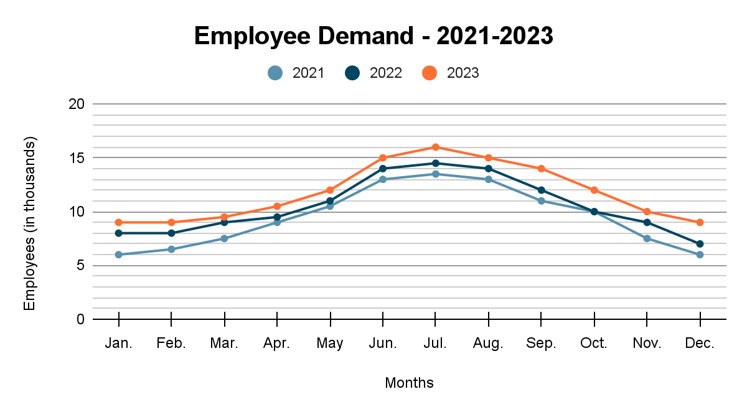

1. What is the trend in employee demand over the three years shown on the graph?

**Each year the demand increases during the spring and summer and decreases in the fall and winter. The number of employees for each individual month has increased each year from 2021-2023.**

1. What might account for the variation in employee demand through the years?

**Seasonal employment opportunities, such as tourism or agriculture.**

1. How many more jobs were there in June 2023 compared to June 2021?

**2,000**

1. Based on the information on the graph, what predictions could you make about employee demand for 2024?

**The number of employees will continue to increase overall, but the fluctuation based on the season will continue.**