**Line Graph Guided Practice**

**Graph 1**

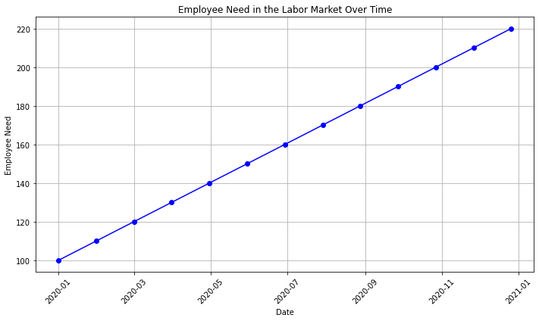

1. What is the title of the graph?
2. What information is on the X-axis?
3. What information is on the Y-axis?
4. According to the graph, is there a demand for employees in the labor market?
5. In March 2020, how many employees were needed in the labor market?
6. How many more employees were added to the labor market between May 2020 and November 2020?
7. Do you think it would be easy or difficult to find a job in this labor market? Why?

**Graph 2**

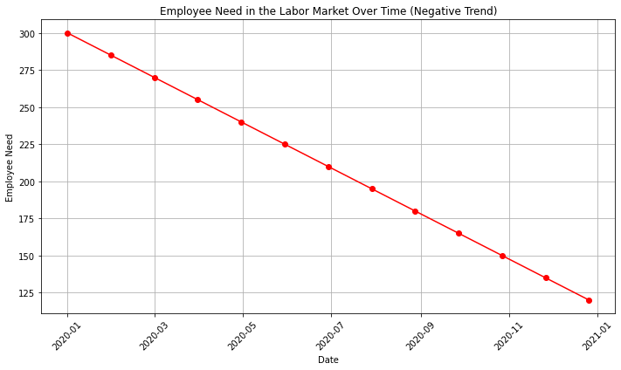

1. According to the graph, is the demand for employees growing? How do you know?
2. How many employees were needed in the labor market in July 2020 compared to January 2021?
3. Do you think it would be easy or difficult to find a job in this labor market? Why?

**Graph 3**

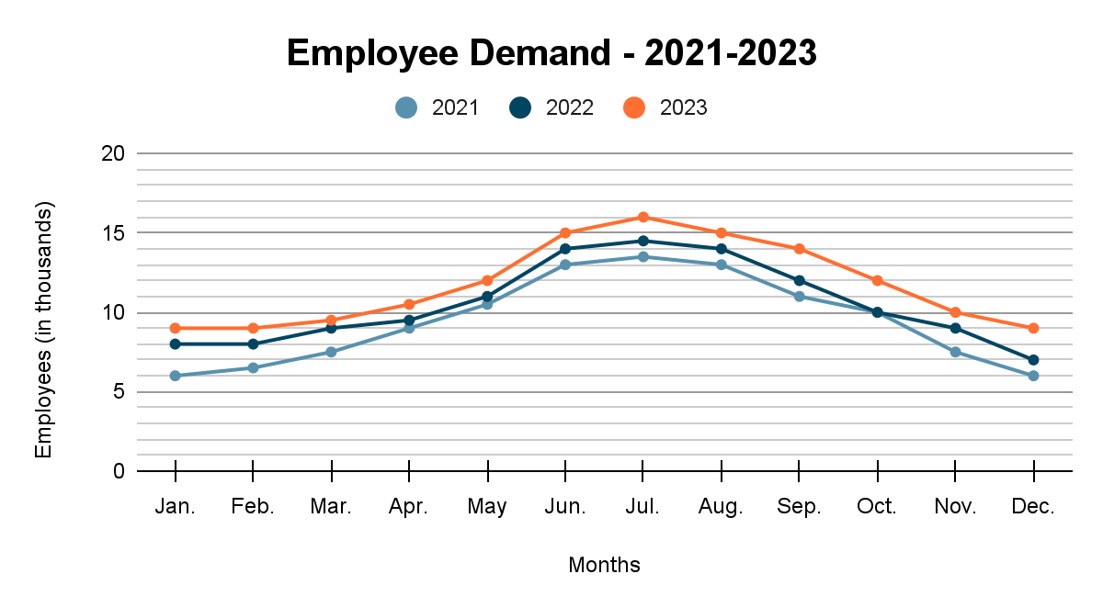

1. What is the trend in employee demand over the three years shown on the graph?
2. What might account for the variation in employee demand through the years?
3. How many more jobs were there in June 2023 compared to June 2021?
4. Based on the information on the graph, what predictions could you make about employee demand for 2024?