**Factors of Production – Independent Practice Activity**

Now that we have learned about the four factors of production, land resources, labor resources, capital resources, and entrepreneurship, as well as how graphs may be used with these different factors, you will have the chance to practice independently what you have learned. Answer the questions. When completed, please submit for review.

**Activity 1: Circle Graph**

Review the graph below and answer the questions provided:

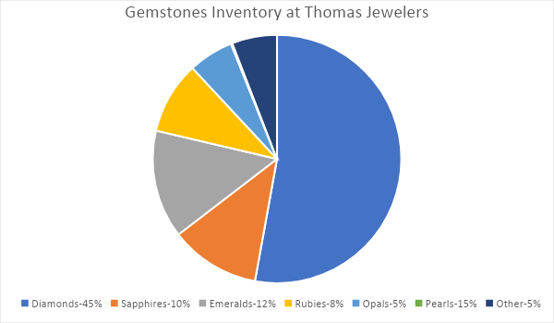

1. What gemstone has the highest percentage?
2. What three gemstones equal 25% of the gemstone inventory?
3. Which factor of production would gemstones be?
4. If there were 500 total gemstones in Thomas Jewelers inventory, how many of each type of gemstone do they have?

|  |  |
| --- | --- |
| **Gemstone** | **Total of Gemstone** |
| Diamonds |  |
| Sapphires |  |
| Emeralds |  |
| Rubies |  |
| Opals |  |
| Pearls |  |
| Other |  |

**Activity 2: Pie Chart**

The chart below represents how money is spent monthly for capital resources for a manufacturing company called Widgets R Us. Remember that capital resources refer to items that are man-made. Suppose the company spends $40,000 monthly on these expenses. For this activity, complete the chart below and identify realistic examples for each type of capital resource and then calculate how much money the company spends each month on these resources.

|  |  |  |
| --- | --- | --- |
| **Expense** | **Example** | **Amount Spent** |
| Manufacturing Equipment |  |  |
| Building |  |  |
| Tools |  |  |
| Computer Software |  |  |
| Company Vehicle |  |  |
| Office Supplies |  |  |

**Activity 3: Bar Graph**

The bar graph below represents the types of labor capital found at Vision Stream Enterprise. Each bar indicates the number of employees that perform the different types of labor tasks indicated under each bar. You can look up examples of each type of labor online if unsure. Study the chart and answer the questions below:

1. Which type of labor has the highest number of workers?
2. Which type of labor has the lowest number of workers?
3. How many employees engage in virtual labor?
4. What two labor types combined have a total of 50 workers?
5. What is the total number of employees at Vision Stream Enterprise?
6. Complete the chart below by defining what the different types of labor are and providing an example of a type of job/career for each type of labor.

|  |  |
| --- | --- |
| **What is…** | **Type of Job/Career Example** |
| Blue Collar Labor |  |
| White Collar Labor |  |
| Management |  |
| Virtual Labor |  |
| Contract Labor |  |

**Activity 4: Entrepreneurial Business – Tracking Sales**

The graph below shows the total sales for Annabelle’s Photography Studio. Annabelle Allen is an entrepreneur who opened her own photography business in 2018. Entrepreneurs combine land, capital, and labor resources in unique ways. The line graph below shows her yearly sales over a five-year period. Please review the graph below and answer the questions below:

1. Which year had the highest number of sales?
2. In what year was the lowest number of sales?
3. What was the number of sales in 2023?
4. There was a significant drop in sales in 2020.  What reason(s) could you give to explain such a significant drop in sales?
5. Use the chart below and identify an example of a land, capital, and labor resource that could be used for this business.

|  |  |
| --- | --- |
| **Topic** | **Example** |
| Land Resources |  |
| Capital Resources |  |
| Labor Resources |  |