**Factors of Production – Guided Practice Activity**

Now that we have learned about the four factors of production: land resources, labor resources, capital resources, and entrepreneurship, you will work in a group or with a partner to complete the four activities below.

**Activity 1**

Sometimes images can tell us a great deal of information about data. Look at the image below and work in a small group or with a partner and answer the following questions:

1. What do you notice about this image?
2. What questions do you have about this image?

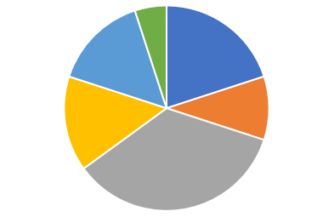

Suppose we add the following information to the image:

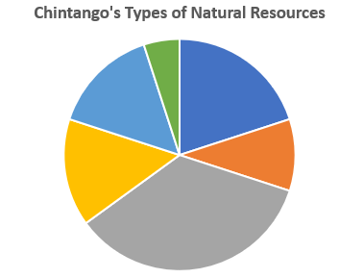

Now answer the following questions with your group/partner:

1. What does the image represent?
2. What are natural resources?
3. What are some examples of natural resources or land resources that you think may be represented in this image?
4. Why are natural resources important to a country’s economy?

Now, let’s look at all the information for this image:

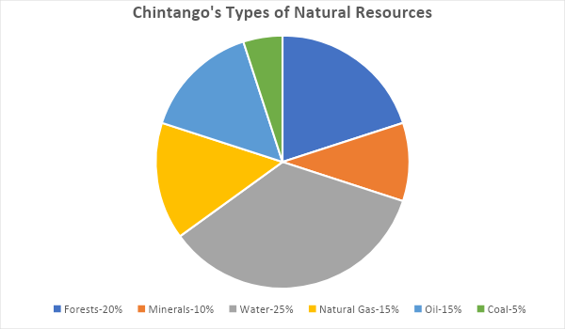

This image, which is called a circle graph or pie chart, is a type of graph commonly used to display information. This graph represents all the different types of natural resources or land capital for a fake country by the name of Chintango. It displays the country’s total amount, or 100%, of the different types of natural resources. Notice that the amount of each resource is represented by a percentage. When added all together, the percentages will total 100. Circle graphs generally represent the information presented by percentages. We can also use the information presented in graphs to make calculations and answer questions. Review the graph above and then answer the following questions in your group:

1. What land resource has the highest percentage?
2. What two types of land resources equals 35%? (Hint: There is more than one combination.)
3. Which land resource is the smallest?
4. Looking at the graph, identify a business that you think would be successful for each type of land resource listed on the chart.

|  |  |
| --- | --- |
| **Resource** | **Type of business and why it would be successful** |
| Forests |  |
| Minerals |  |
| Water |  |
| Natural Gas |  |
| Oil |  |
| Coal |  |

**Activity 2**

Let’s reinforce what we’ve learned about pie graphs. The chart below represents how money is spent monthly for capital resources for SkyLink Financial Planners, a retirement and investment company. Capital resources are items that are man-made. Suppose the company spends $100,000 monthly on these expenses. For this activity, work with a partner to complete the chart below and identify two realistic examples for each type of capital resource. Then calculate how much money the company spends each month on these resources. A calculator can be used for this assignment.

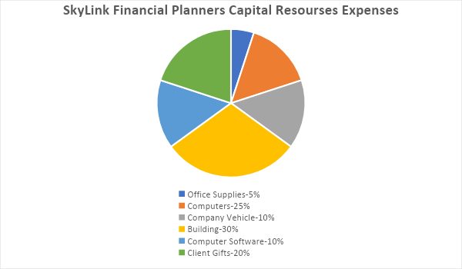

|  |  |  |
| --- | --- | --- |
| **Expense** | **Examples** | **Amount Spent Monthly** |
| Office Supplies | 1.  2. |  |
| Building | 1.  2. |  |
| Computers | 1.  2. |  |
| Computer Software | 1.  2. |  |
| Company Vehicle | 1.  2. |  |
| Client Gifts | 1.  2. |  |

**Activity 3**

Let’s look at the image below and then answer the following questions:

1. What do you notice about this image?
2. What questions do you have about this image?

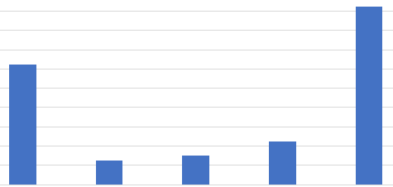

Now, let’s add the following information to the image:

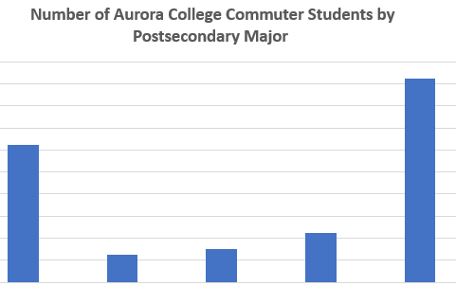

Commuter students are students that drive to school each day for class, rather than living on campus in a dormitory. Now answer the following questions with your group/partner:

1. What does the image represent?
2. What kinds of information do you think will be provided on this graph?
3. If labor resources are the effort people give to make goods and provide services to earn wages, such as working a job, how does this information relate to labor resources?
4. What are some college majors you think may be represented in this image?
5. Why would a college want to know this type of information?

Now, let’s look at the complete image:

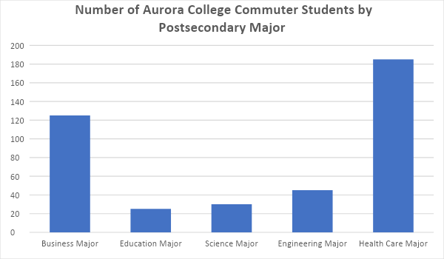

This is another common type of graph, called a bar graph. It is another way that data can be represented visually. There is the Y axis, which represents one part of the data, and the X axis, which represents another piece of the data. For example, the X axis in this graph identifies the different types of majors for commuting students. The Y axis represents the number of students.

Work with your group/partner and answer the following questions:

1. Which major has the highest number of commuting students?
2. Which major is the lowest number of commuting students?
3. How many commuting students are business majors?
4. What is the total number of commuting students for all majors?
5. Use the chart below and identify two types of careers for each type of major listed above.

|  |  |
| --- | --- |
| **Major** | **Types of Job/Careers** |
| Business | 1.  2. |
| Education | 1.  2. |
| Science | 1.  2. |
| Engineering | 1.  2. |
| Health Care | 1.  2. |

**Activity 4**

Let’s look at another image. Work with your group or partner and answer the following questions:

1. What do you notice about this image?
2. What questions do you have about this image?

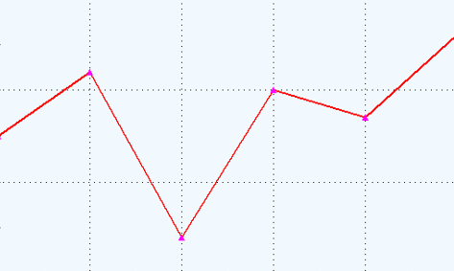

Now let’s add the following information to the image:

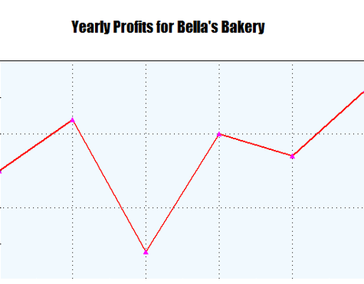

If you remember, profits are the income paid to entrepreneurs for goods and services that they provide. Now answer the following questions with your group/partner:

1. What does the image represent?
2. What kinds of information do you think will be provided on this graph?
3. If profits are the income paid to entrepreneurs for the goods and services that they provide, why would tracking this information be important?
4. What would be some examples of capital and labor resources for this type of business?

Now, let’s look at the complete image:

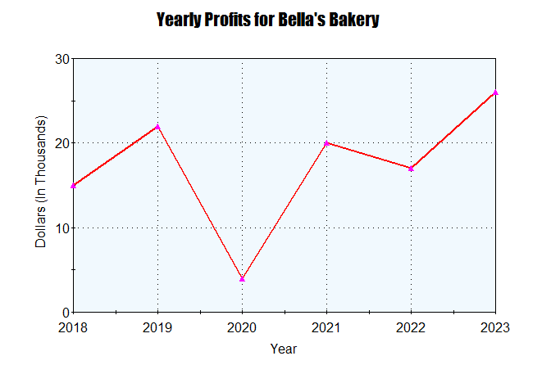

This is another common type of graph, called a line graph. It is another way that data can be represented visually. There is the Y axis, which represents one part of the data, and the X axis, which represents another piece of the data. For example, the X axis identifies the years over time. The Y axis represents the amount of profit.

Work with your group/partner and answer the following questions:

1. Which year has the highest profits?
2. Which year had the lowest profits?
3. How much profit did Bella’s Bakery make in 2021?
4. What reasons could account for the decrease in profits in the years 2020 and 2022?
5. Use the chart below and identify three types of land, capital, and labor resources that could be used for a bakery business and identify three ways that Bella’s Bakery can make profits:

|  |  |
| --- | --- |
| **Topic** | **Examples** |
| Land Resources | 1.  2.  3. |
| Labor Resources | 1.  2.  3. |
| Capital Resources | 1.  2.  3. |
| What are three ways that Bella’s Bakery can make profits? | 1.  2.  3. |

Conclusion:

In the activities, we have discussed the four different factors of production and how information about these factors can be represented using different types of graphs.

You will now complete some independent activities using these types of graphs.