Skill Overview
Directions: Read about the skill and then complete activities to practice the skill.


What does it mean to recognize bias, assumptions, and multiple perspectives?
This means understanding that people may have different experiences, thoughts, and opinions. It also means listening to others and working together, even when people do not agree on everything.


Why are these skills important?
These skills help you think carefully before making decisions about people and situations at work, home, school, or in your community. They also help you consider multiple options before making a final choice.
Everyone has biases and makes assumptions, even if they do not realize it.
A bias is an opinion about whether a person, group, or idea is good or bad that influences how you deal with something.
An assumption is something that you think is true although you have no definite proof.


How can you improve these skills?
You can improve these skills when you:
- Understand how your own thoughts might affect what you say or how you listen.
- Respect differences in a group and cooperate to get things done together.
- Notice when something isn’t fair.
- Explore options, experiences, and facts from several sources to learn more.
- Listen to multiple perspectives, even if you disagree.

Skill Practice
Directions: Read one or more scenarios to practice your skills.

Scenario 1: Hiring Decision

You are an assistant manager in the produce department at your local grocery store. Your department needs to hire another person to help stock food. Your supervisor tells you about three people who applied for the job. Then, she asks for your opinion.
- Emily has a high school diploma but no work experience.
- Fatima has a high school diploma and work experience. English is not her first language.
- Luis passed the high school equivalency tests and has some work experience.
The manager says, “I prefer to hire people with a high school diploma. It shows they worked harder.”
Luis does not get an interview.

Answer the following questions and be prepared to explain your answer.
- What is the manager’s bias?
- What is the manager assuming?
- Is this fair? Why or why not?
- What information is missing?
- What should the manager do differently?

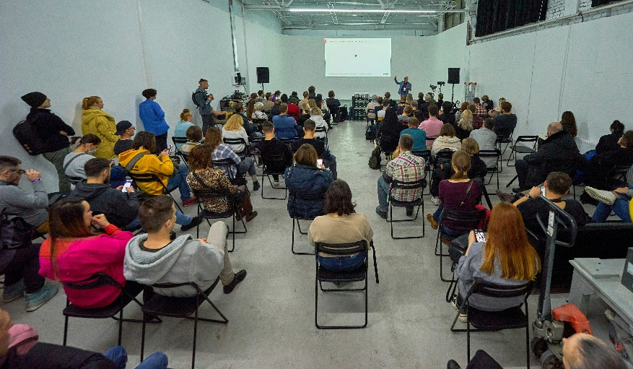
Scenario 2: Community Meeting

Your city’s adult education program needs more space for classes because enrollment has increased. Other programs also need space. You are at a community meeting about this issue. You want to share an idea, but first you listen to other community members talk. You are surprised by a few of the opinions.
Some people say:
- “If adults didn’t finish school before, they probably won’t finish now.”
- “People should learn English before they come to this country.”
- “Older people can’t learn new information. It’s too late for them.”
Other people say:
- “Adult education helps people get jobs and support their families.”
- “ESL classes help people improve their English so they can participate more in the community.”

Answer the following questions and be prepared to explain your answer.
- Underline one statement that shows bias.
- What does the speaker believe or assume?
- Is this fair? Why or why not?
- Who could this decision affect?
- What is your opinion about this issue?

Skill Application
Directions: Use this space to reflect on how you might use this skill at work, home, school, or in your community.

