Skill Overview
Directions: Read about the skill and then complete activities to practice the skill.


What does it mean to process and analyze information?
This means thinking carefully about information to understand it and use it.


Why are these skills important?
These skills can help you at work, home, school, or in your community. They will help you:
- Understand information more clearly.
- Make smart choices.
- Solve problems more easily.
- Notice mistakes or false information.
- Prepare for new situations.


How can you improve these skills?
You can improve these skills when you:
- Think about what might happen in different situations.
- Stay focused and ignore distractions.
- Notice when information is missing.
- Think about how one thing can cause another to happen.
- Know when a problem needs quick attention.
- Use information from different sources before making a decision.

Skill Practice
Directions: Look closely at the photo. Answer the questions to help you study the information, predict what may happen, and identify missing information. Be prepared to discuss your answers.

Questions
- What do you see?
- What do you think is happening?
- What might happen next?
- What in the photo makes you think that?
- What information might be missing that would help you understand the photo better?
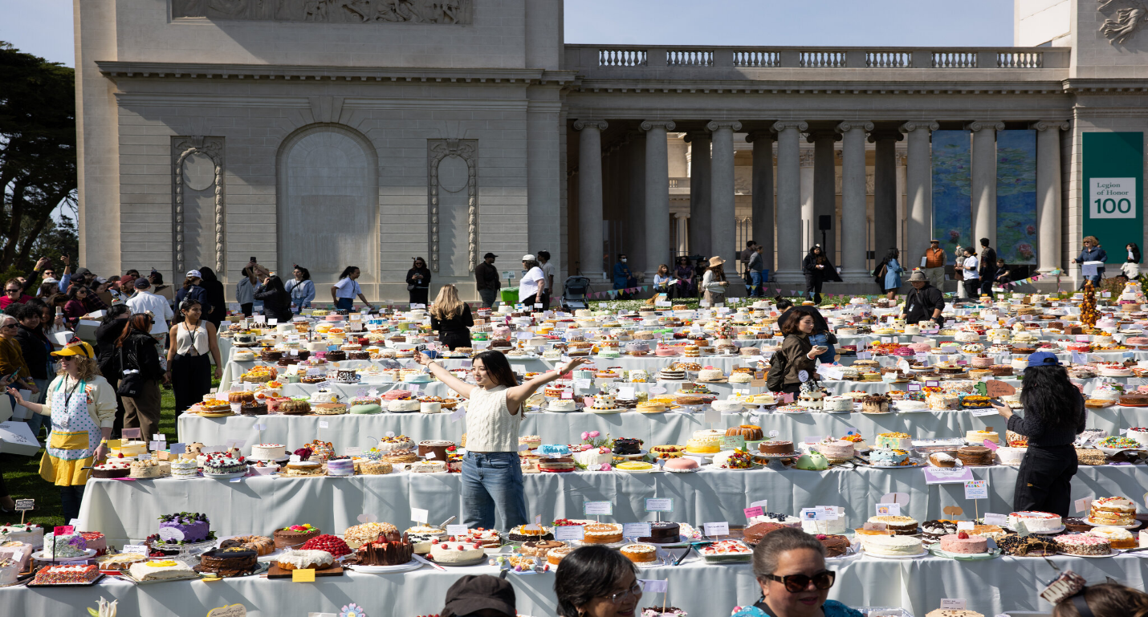

Skill Application
- Have you experienced something like this before? If yes, describe it to someone or write a few sentences about it.
- How could you use processing and analyzing information skills at work, home, school, or in your community?

